Deploying the SimpleLTC Browser Extension using Active Directory

This document provides helpful information on SimpleLTC as well as SimpleLTC’s Chrome Extension and how to deploy it through Microsoft Active Directory.
1. About SimpleLTC
SimpleLTC, a Netsmart Solution, creates long-term care software for regulatory compliance, reimbursement optimization, and quality measurement. Our software is designed to simplify healthcare data, improve workflow processes, and increase reimbursement.
Over 30 million MDS assessments have been processed and archived by our software, making SimpleLTC the largest third-party transmitter of MDS 3.0 assessment data. Because Simple products are maintained and updated in the cloud, we have unique visibility into the real-time performance and clinical data of thousands of providers, which helps ensure that forms are managed correctly, data and analytics are accurate, and that providers achieve optimal reimbursement for the care they deliver.
2. About SimpleLTC’s Chrome Extension
To better integrate SimpleLTC’s services with a facility’s existing Electronic Health Record (EHR), SimpleLTC has created a Chrome extension. This extension allows facilities to seamlessly submit and analyze MDS assessments without leaving the EHR, greatly simplifying your facilities’ workflow.
3. Why SimpleLTC Has Elected Not to Use the Chrome Web Store to Deploy Their Extension
Simple has elected not to publish its extension on the Chrome Web Store to provide better service and security to its customers. Google does not allow companies to publish extensions to their customers privately, and each published extension and update can take two (2) to four (4) weeks to be approved by Google. By hosting the extension outside of the Chrome Web Store, SimpleLTC can provide an improved user experience, enhanced security, and instant updates.

Deployment Process:
The Deployment Process within Microsoft Active Directory is straight-forward. This guide will give you the ins and outs of setting up the Registry Files in Active Directory:

Step 1: Log into your Active Directory server and open Group Policy Management. Once it’s opened, you should be able to add a new Group Policy, and can name it something clever, like MDS Extension, as shown here:
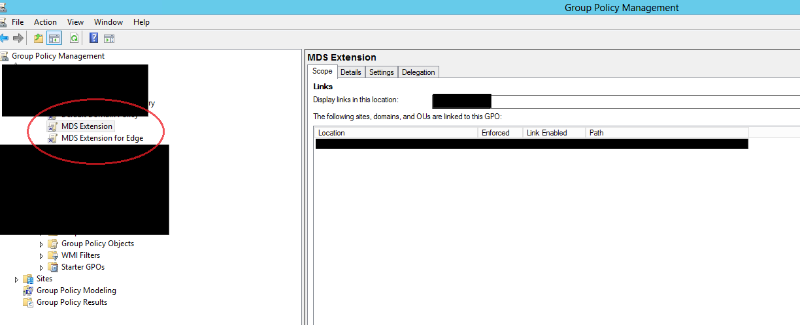
Step 2: After creating your new GPO, you should select what computers or users this new policy will be rolled out to. We recommend using the hive “HKEY_LOCAL_MACHINE”, so in this specific example, we have our end user computers under the Security Filtering:
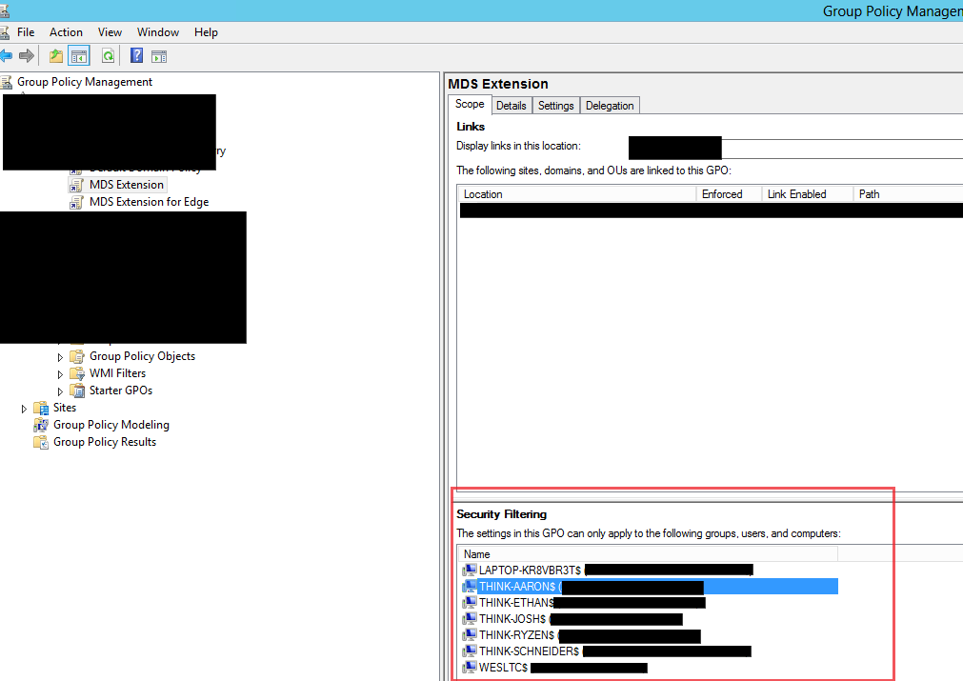
Step 3: Right-click on the newly created GPO, and “Edit”. Group Policy Management Editor should open, and it will look something like this:
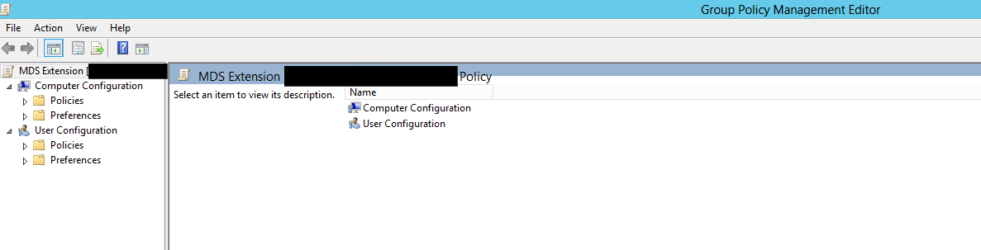
Step 4: As mentioned in Step 2, we recommend using the hive “HKEY_LOCAL_MACHINE”, so for this step, we’ll be focusing specifically on “Computer Configuration”. Under “Computer Configuration”, use the arrow to open the “Preferences” folder, and then open the folder “Windows Settings”. Under “Windows Settings”, you’ll see the “Registry” section. When you click on “Registry”, you’ll have an nice, blank “Registry” page appear:
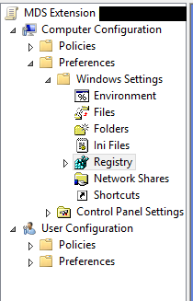
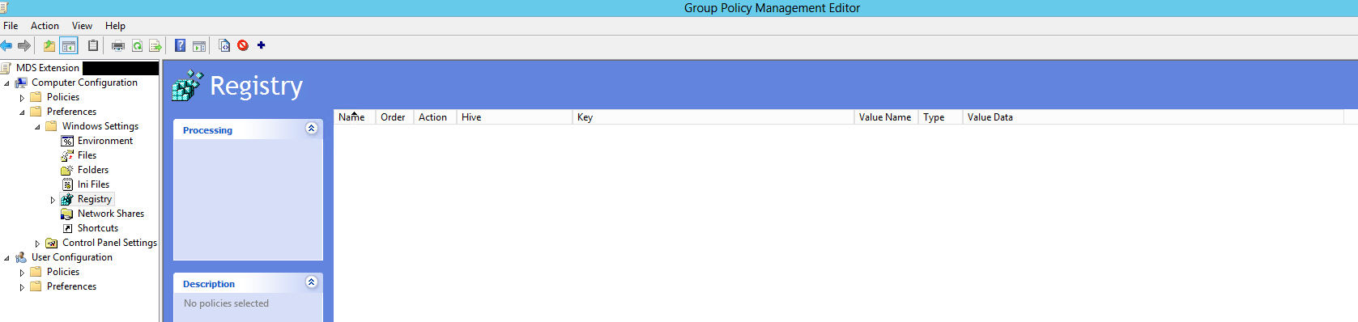
Step 5: Right click anywhere on the “Registry” page, and you’ll want to hover over the “New” option, and select “Registry Item”:
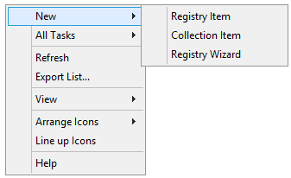
Step 6: When you create your new “Registry Item”, you’ll be prompted to add some details under the “Properties”:
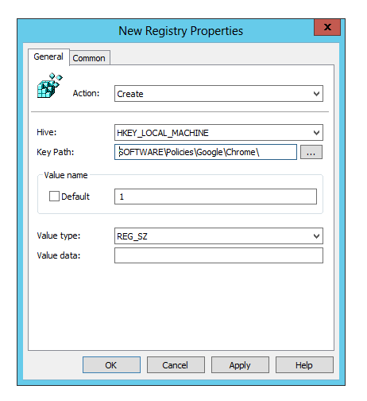
These are the most important pieces of information for successfully creating “Registry Items”:
- Make sure to change the Action from “Update” to “Create”.
- The hive, “HKEY_LOCAL_MACHINE”, should already be specified. The Key Path does not need the hive added onto it, it’s the rest of the branch that is needed to specify the location of the registry key.
- The Value name should be “1”.
- The Value type will remain “REG_SZ”.
- The Value data will be given in the full breakdown of each item; you’ll need to create 3 items total.
- Once you have filled out the information, be sure to hit “Apply”, and then “OK”.
Step 7: The full paths will be outlined below; once you’re done creating all three registry items, your “Registry” page should look identical to this:
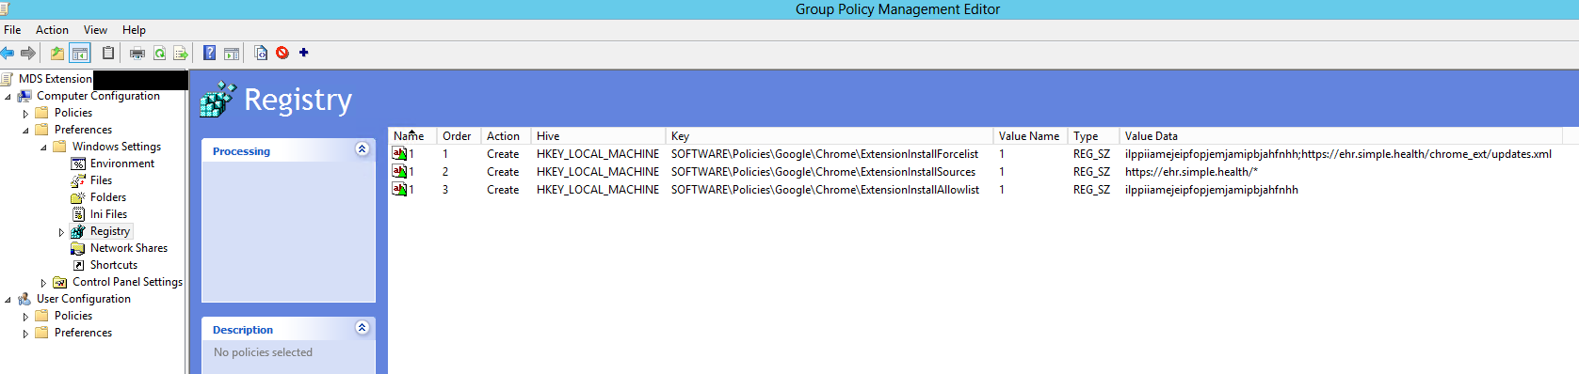
The three items, and their Value data, should be as follows:
The first “key” should be SOFTWARE\Policies\Google\Chrome\ExtensionInstallForcelist and its Value data will be ilppiiamejeipfopjemjamipbjahfnhh;https://ehr.simple.health/chrome_ext/updates.xml
The second “key” should be SOFTWARE\Policies\Google\Chrome\ExtensionInstallSources and its Value data will be https://ehr.simple.health/*
The third and final “key” should be SOFTWARE\Policies\Google\Chrome\ExtensionInstallAllowlist and its Value data will be ilppiiamejeipfopjemjamipbjahfnhh
Step 8: Make sure you’ve specified the user computers, and have your users restart their PCs, to pull in the new policy. If the policy is pulled in after a restart, you’ll want to check the Jigsaw piece on Chrome to see if the Extension exists underneath it. There’s a button to pin it, if it is present; it should be a blue button with a white “S” in it. Congrats! The Browser Extension is on the end user’s computer, and can be used within PCC, once the user is signed in.

Caveats to the Extension:
First, there’s a possibility that Chrome hasn’t updated, and it may take it a while to pull in the policy/show that the extension is present. You can verify this by opening Chrome on a user’s computer and navigating to chrome://policy. The policy keys we created in the GPO should show up, as shown here:
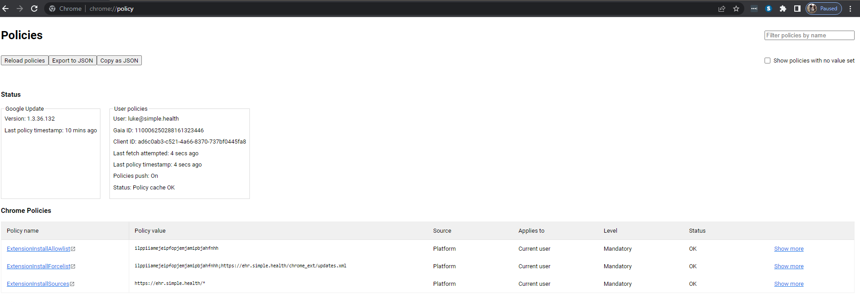

Second, if you, the IT professionals, have the desire to use a x64-bit rollout, an update to the paths will require that specification. You’ll need to add the WOW6432Node to the key path. As an example:
SOFTWARE\Policies\Google\Chrome\ExtensionInstallSources will become SOFTWARE\WOW6432Node\Policies\Google\Chrome\ExtensionInstallSources.
Using the x32-bit policies, the ones mentioned above, have worked since the initial creation and rollout of the Browser Extension. The x64-bit policies should only be used if there is an extreme lockdown of the end user computers

Finally, you can deploy the Browser Extension to Edge, if end users do not/cannot use Chrome, for whatever reason. The keys will alter slightly again, using \Microsoft\Edge\ instead of \Google\Chrome\.

