Deploying the Simple Browser Extension using Gsuite
To deploy policies to User profiles on Chrome, for access to the SimpleLTC Browser Extension that fully integrates with PCC, follow these simple steps to set up the policies in Chrome.

- Go to the Google Admin Page: https://admin.google.com and navigate on the left hand side to the following path: Devices Chrome Settings Users & Browsers. 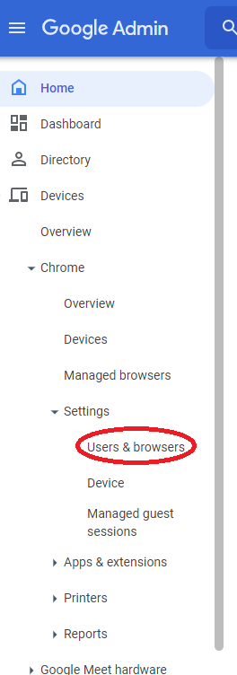
- When you get to the Users & Browsers Page, you’ll need to select the proper Organizational Unit (OU) that you want to be under. If you want to deploy it to all users, remain on the primarily OU that is the parent OU to your other OUs. For my example, the OU that I want is “luke chrome test”.
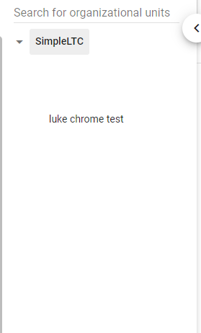
- Under the OU, there is a section under the User & Browser Settings labeled “Apps and Extensions”. There are two hyperlinks in this section; you should open both in new tabs. 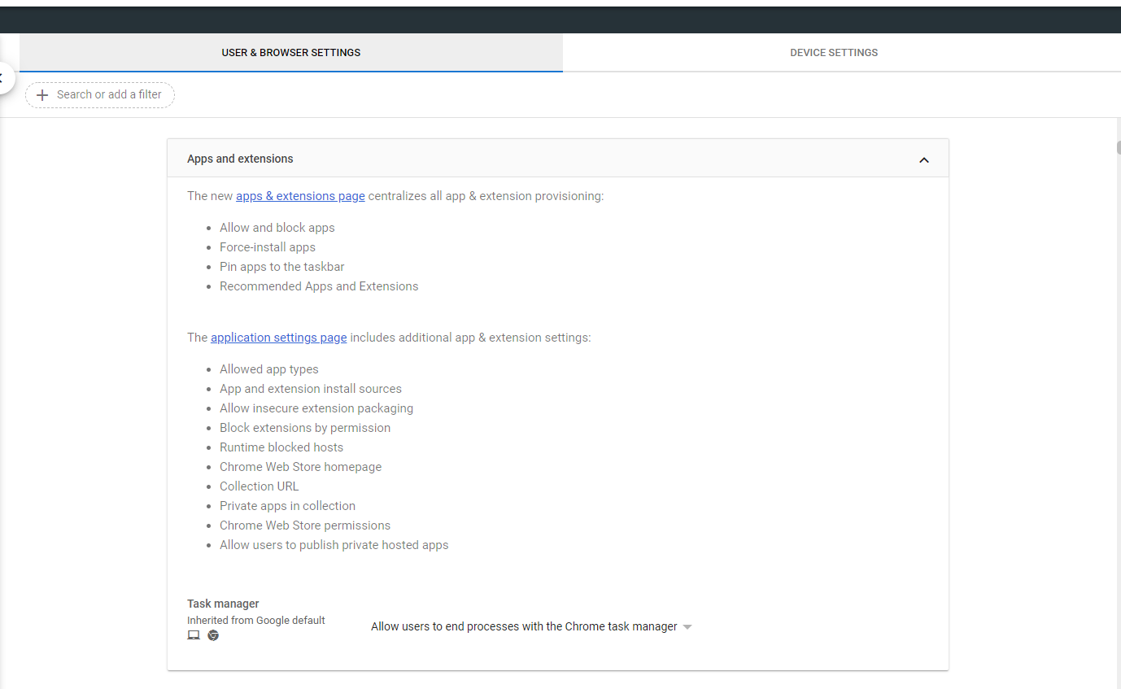
- Under the Additional User App Settings (the second hyperlink mentioned in step 3), you will need to find the section that’s labeled “App and extension install sources” and add the following URL: https://ehr.simple.health/*. Once it’s added, you will need to save this setting. 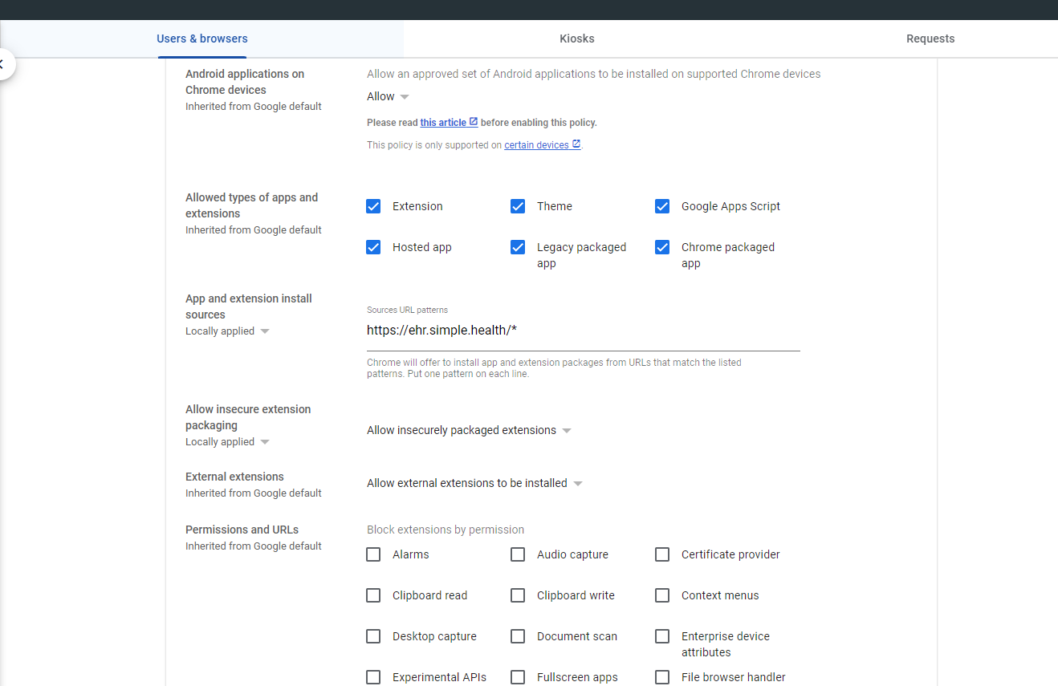
- Under the App Management tab (the first hyperlink mentioned in step 3), there is a yellow plus sign; there are a few options to add extensions here, but the one we want is to “Add Chrome app or extension by ID”. When you click on this, there will be fields for you to input. The Extension ID should be ilppiiamejeipfopjemjamipbjahfnhh and then in the section below that, there will be a down arrow to either select “From the Chrome Web Store” or “From a custom URL”. Select “From a Custom URL”, and add this URL: https://ehr.simple.health/chrome_ext/updates.xml. 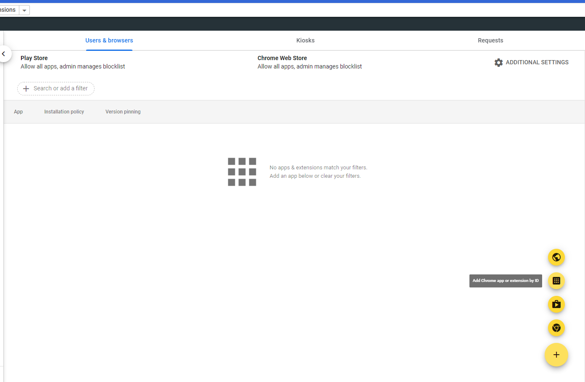
- By default, this will appear as “Allow Install”. There is a down arrow next to “Allow Install”. When you click on the arrow, 4 options appear: “Block Install”, “Allow Install”, “Force Install”, and “Force Install + Pin”. To make sure your users can access the browser extension with no issues, select “Force Install + Pin”. After changing the option, you will need to save this setting. That will make the Simple Extension button appear in the upper right hand corner, by the jigsaw puzzle piece and the user icon. 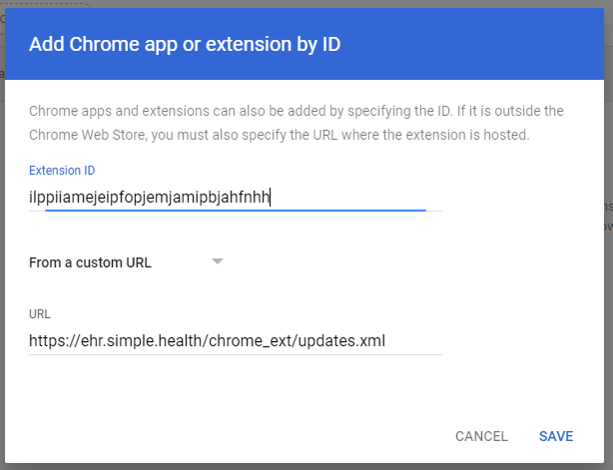
- Additionally, when you click on the newly created object with the ID, a side drawer slides out, and you have several options that you can adjust. Scrolling down to the bottom, you’ll see the Installation URL, and then directly below that, “Update URL”. By default, it is set to “Updatecheck URL provided in the extension manifest”. You will need to click on the down arrow to the right, and select “Installation URL (see above)”. This will set it so when we push out any updates to the Browser Extension, you will not need to manually do any work to get these updates; it will automatically update the Browser Extension for your users. It may take a full reboot of Chrome, or even the user’s PC for the updates to take effect.
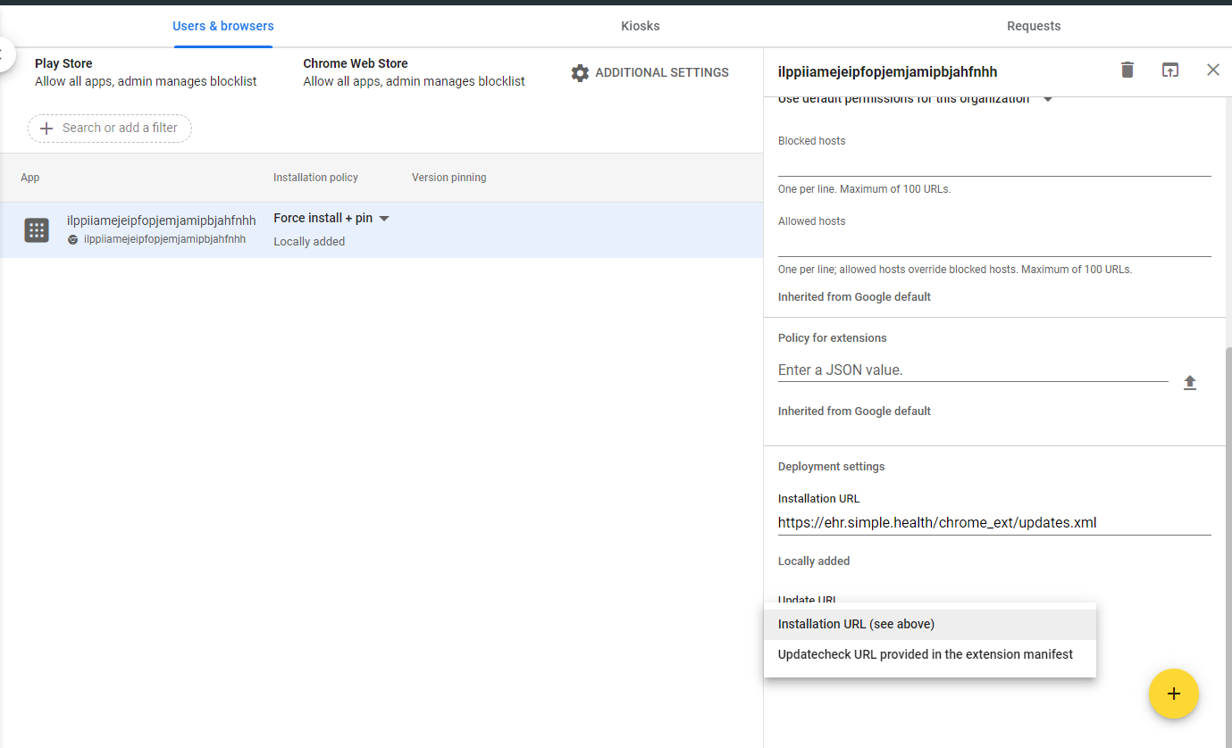
- If the blue button with the white “S” appears, and your user’s chrome://policy page looks similar to the image provided below, it should function on PCC as intended. 