Step-By-Step MDS Transmission Guide
For SimpleLTC Browser Extension Users

The SimpleLTC browser extension allows users to analyze their MDS assessments before they are locked, transmit batches, and record CMS Final Validation results in one simple workflow.
Contact support at support@simpleltc.com or (469)-916-2803, Mon-Fri from 7a-7p CST.

Step 1 - Complete your assessment in PCC as you normally would. Just before locking the assessment, the blue simple. button will be activated.

Step 2 - Click the blue simple. button before you lock the assessment to view your assessment analysis. SimpleLTC will open a new window with your scrubber results. Review these results and make corrections as necessary.

Step 3 - Lock the assessment once all necessary adjustments are made. This will update the assessment to “Export Ready” status.

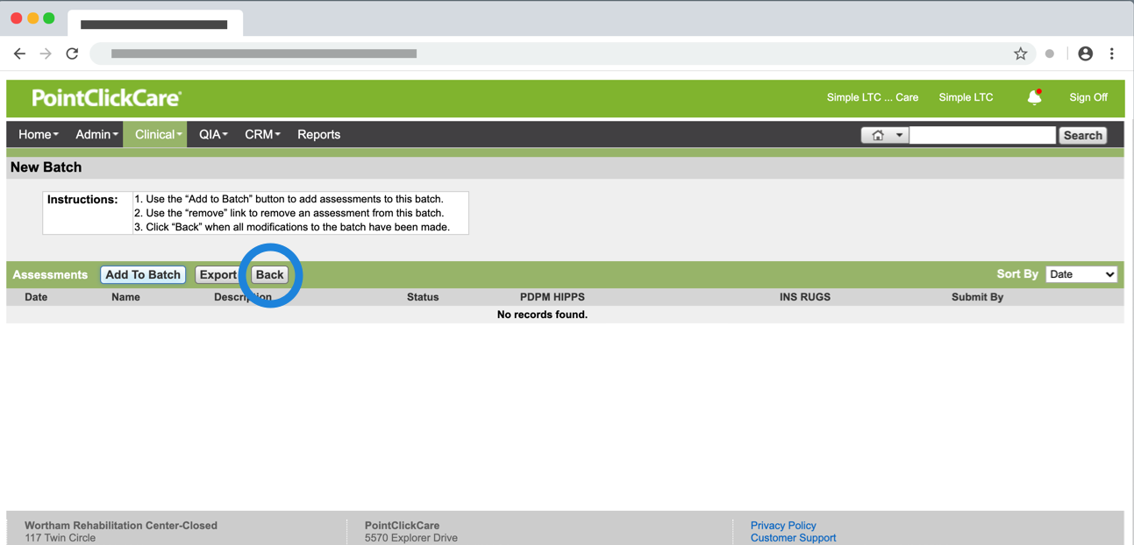
Step 4 - Create batches of “Export Ready” assessments from your MDS 3.0 Batches screen. When you add assessments to a batch, make sure to click the "BACK" button. Do not click EXPORT.

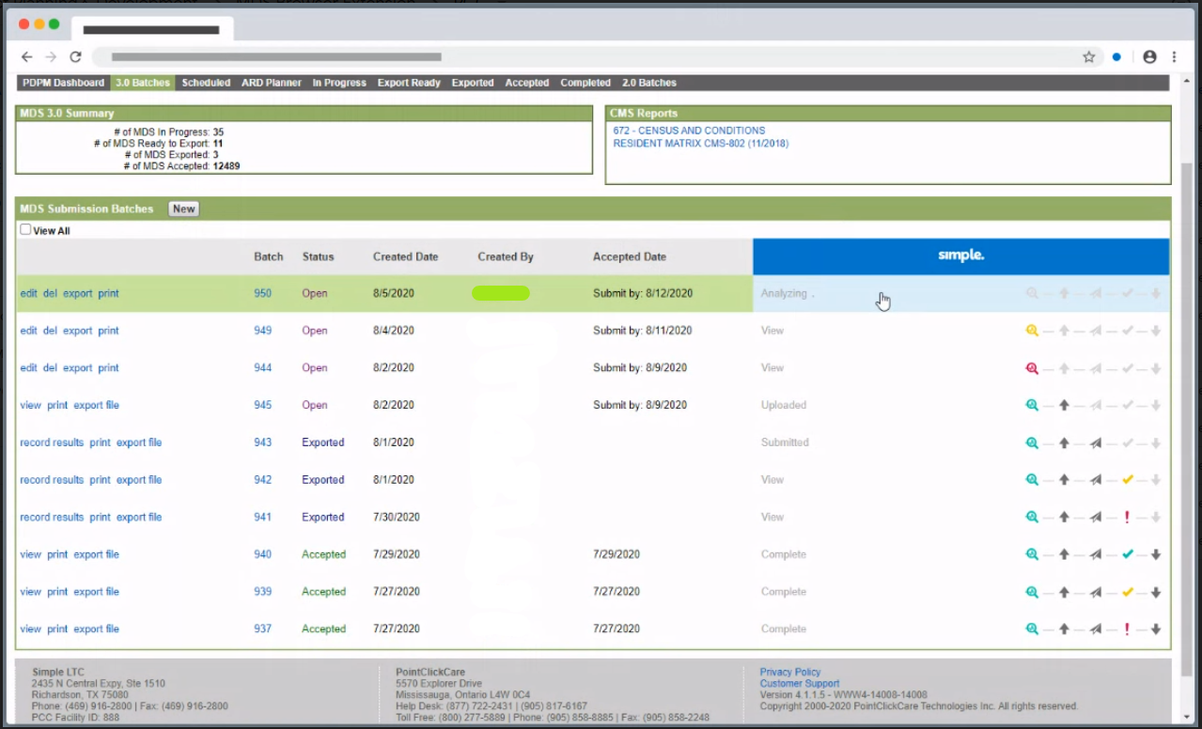

Step 5 - SimpleLTC will analyze batches and enable the magnifying glass in the simple. progress tracker when your batch report is ready for review.

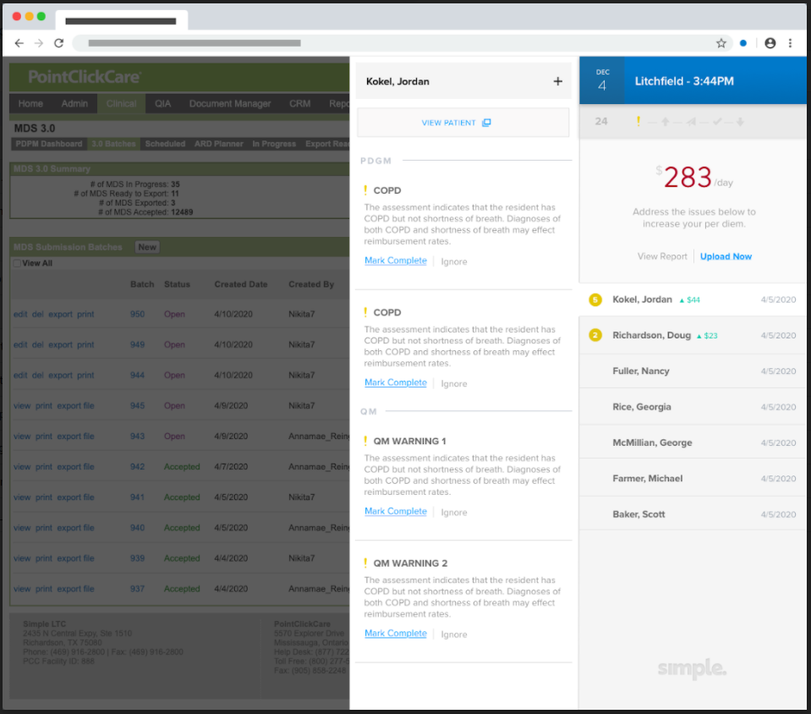

Step 5 - Click the magnifying glass to review the analysis results for the assessments in the batch. Click Upload Now when the batch is ready to be transmitted to CMS.

Step 6 - SimpleLTC will transmit the batch to CMS and enable the check mark when the Final Validation is available from CMS. User’s should click on the View button to verify the results and save the batch.

Frequently Asked Questions
- What do the icons on the batch table progress tracker mean?
The simple. progress tracker on the MDS Submission Batches table has 5 icons indicating the different stages a batch goes through during transmission.
Icon Color | Magnifying Glass | Up Arrow | Airplane | Check Mark | Down Arrow
Grey | Analysis report in process | Uploaded to SimpleLTC | Transmitted to CMS | Final Validation in process | Download Final Validation
Yellow | Flags on analysis report | NA | NA | Warnings on Final Validation | NA
Red | Critical flags on analysis report | NA | NA | Fatal errors on Final Validation | NA
Green | No flags on analysis report | NA | NA | No warnings on Final Validation | NA

- How do I finalize a batch in “Exported” status?
When the CMS Final Validation report is available, the View button will be enabled for the batch. Click on this button to review the results and save the batch. Your batch should now be in “Accepted” status.
3. Why can’t I save my validation results?
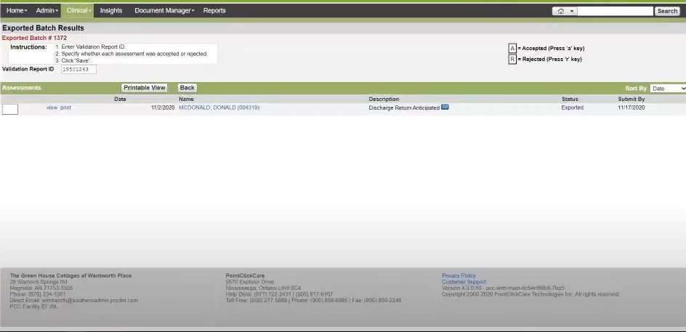
Some PCC users require the Submission ID to be saved. If this is occurring please enter the Validation Report ID and mark Accepted/Rejected.

